Software Requirements Specification

Version <1.1>

May 25,2020

**Job search site**

**Bakhiet Mohamad TeamLeader**

**Kamal Nasser Tayfour**

<<Any comments inside double brackets such as these are not part of this SRS but are comments upon this SRS example to help the reader understand the point being made.

Refer to the SRS Template for details in the purpose and rules for each section of this document.

The Students who submitted these project were Kamal Tayfour, Bakhiet Mohamad.>>

Table of Contents

|  |  |
| --- | --- |
| Table of Contents………………………………………………………………………………...i | |
| List of Figures……………………………………………………………………………………….ii | |  |
| 1.0. Introduction......................................................................................4 | |
| 1.1.Purpose………………………………………………………………………………………....4 | |  |
| 1.2. Scope of Project ……………………………………………………………………….…..4  1.3. Glossary…………………………………………………………………………………………5  1.4. References…………………………………………………………………………………….6  1.5. Overview of Document……………………………………………….….………….….6  2.0. Overall Description……………………………………………………….7  2.1 System Environment……………………………………………………….……….….…7  2.2 Functional Requirements Specification……………………………….….….…..8  2.2.1 Employee Use Case……………………………………………………….…….….8  2.2.1 Employee Use Case……………………………………………………….…….….9  2.2.2 Company Use Case………………………………………………………………..10  2.3 User Characteristics……………………………………….….………………………….11  2.4 Non-Functional Requirements…………………………………………………….…11  3.0 Requirements Specification…………………………………………….….11  3.1 External Interface Requirements…………………………………………………..11  3.2 Functional Requirements………………………………………………………………12  3.3 Detailed Non-Functional Requirements…………………………………….….13  3.3 Detailed Non-Functional Requirements…………………………………….….14   1. **Introduction**   ***1.1 Purpose***  The purpose of this document is to explain how the system works to create job opportunities. How to register in the system and create an employee or company account, how to search and apply for a job if the account is a company account and not an employee, and how to search for an employee  The behaviors, user interface and interaction details of the website will be fully described.  With this document, the project team will have the  Ability to fully understand the system  ***1.2 Scope of Project***  This system is a system to create job opportunities so that it facilitates finding the best job opportunities for the person who is looking for a good job opportunity that meets his needs and requirements. As for companies, through this system, they can search for the best employees and workers and keep pace with the labor market in the best way.  It also leads M This system is easy to communicate between the two parties  ***1.3 Glossary***   |  |  | | --- | --- | | ***term*** | ***Definition*** | | The employee | The person who is looking for a job opportunity and is able to apply for it. | | The company | is the one that provides job opportunities for people. | | Employment applications | It is a CV of each person and what his experiences are. | | Business | These are the professions that the company needs. | | Job application | The person looking for work sends his CV or personal details to the company. | | Experience | The person applying for the work should state his / her experience. | | The company | The company must determine the minimum and the maximum salaries. | | Database | It contains all information of system users and people who are looking for job opportunities and available job opportunities. | | Stakeholder | Any person with an interest in project who is not a developer. |   ***1.4 References***  IEEE. *IEEE Std 830-1998 IEEE Recommended Practice for Software Requirements Specifications.* IEEE Computer Society, 1998  ***1.5 Overview Document***  The next chapter, the Overall Description section, of this document given an overview of the functionality of the product.  It describes the informal requirements and is used to establish a context for the technical requirements specification in the next chapter.  The third chapter, Requirements Specification section, of this document is written primarily for the developers and describes in technical terms the details of the functionality of the product. | |  |
|  | |  |
|  |

**2.0 Overall Description**

***2.1 system Environment***

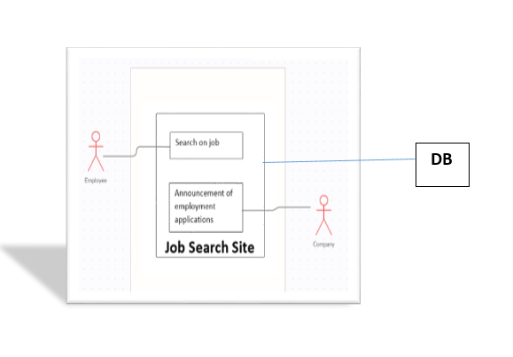

The job search site contains two active entities, the first is people who want to get a job opportunity.

The second are the people responsible for managing the account of the company looking for employees. A person who is looking for a job opportunity reaches the company through the advertisement that the company publishes to obtain new employees.

The company reaches out to the employees who are looking for their expertise by announcing the employee to search for a job opportunity

***2.2 Functional Requirements Specification***

The job search system contains two active actors and one system

Employee Use Case: Job Search

First Description: After connecting to the internet and entering a website ......

1. The employee logs into the site
2. The employee searches for a job opportunity that suits him by entering some information such as the place of work that suits him, the working hours and the type of work, whether partial or full
3. After entering the basic information, the employee requests all the jobs from the system based on the information he entered
4. The system fetches all available job opportunities based on what the employee has entered
5. Employee can now browse job opportunities

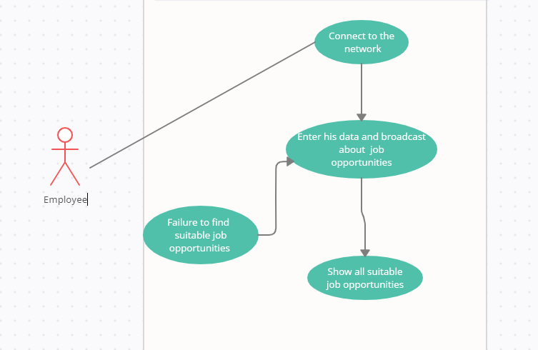

1. Company Use Case: After connecting to the internet and entering the site ......
2. The person responsible for the account of this company logs in
3. After logging in, this account can announce that the company needs employees with specifying some details the basic for the
4. job, such as the location of the company or work, working hours, and the field of work

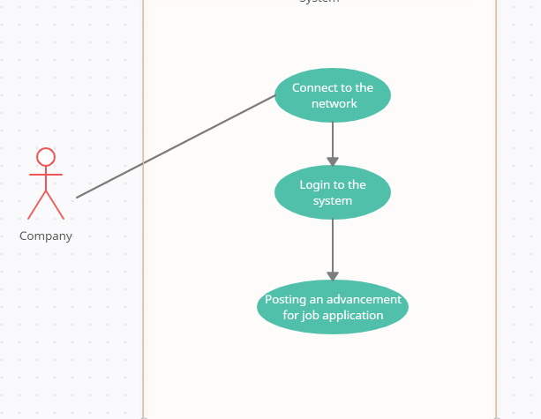

***2.3 User Characteristics***

It is expected that system users have the ability to access the Internet and the presence of a search engine to reach a site

It is better if the person looking for a job opportunity knows how to upload the profile to apply for a job

It is preferable for the company to be able to deal with entry fields, drop-down menus, buttons and links

***2.4 Non-Functional Requirements***

* Data integrity
* safety
* Organization
* Ease of management.
* Convenience of Use
* Reliability.
* Serviceability.

**3.0 Requirements specification**

* 1. ***External Interface Requirements***

The only link to an external system is to link to a database to save user data and fetch information of people looking for job opportunities and companies looking for employees.

* 1. ***Functional Requirements***

***Employee***

|  |  |
| --- | --- |
| Log in | The employee logs into the site |
| Search to job | The employee searches for a job opportunity that suits him by entering some information |
| Order the jobs | the employee requests all the jobs from the system based on the information he entered |
| other | Employee can now browse job opportunities |

***Company***

|  |  |
| --- | --- |
| Log in | The person responsible for the account of this company logs in |
| Publishing post appointment | After logging in, this account can announce that the company needs employees with specifying some details the basic for the job |

* 1. ***Detailed Non-Functional Requirements***

The active bodies in the system must create an account in it to be able to use the system and enjoy its advantages

The system must be connected to a database to save the system users&#39

The system must have ease of use to facilitate the work of users and enjoy its advantages

The system must have a high reliability degree to ensure securing job opportunities for people who are looking for job opportunities and to guarantee employees for companies looking for employees.

The active authorities must provide the system with all the data to cover all other active inquiries

The system must be available at all times

The system should be available on all

operating systems and different screen sizes

The system should have a high degree of administration and organization for ease of use